AQA A Level Psychology - Approaches Knowledge Organiser – Term 1
Key Words | Social and Cultural Context | Psychodynamic - FREUD
Psychology  Approaches  Biological  Cognitive  Behavioural  Empirical  Reductionism  Hypothesis  Models  Predict  Classical conditioning  Operant conditioning  Psychodynamic  Nature  Nurture  Psychosexual  Serotonin  Dopamine  Evolution  Theory  Application  Schema  Environmental  Emotional  Conscious  Unconscious | 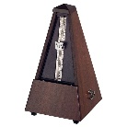  Origins of Psychology  Philosophical roots which led to Wundt opening the first experimental lab in Germany in 1879.  Introspection – examining your thoughts, feelings, emotions and sensations. Metronome used -->first attempt at a control lab  Psychology as a Science – needs to be empirical, objective, reliable with a hypothesis and general laws.  Strengths – led to development of alternate approaches/real life application  Limitations – reductionist/subjective/non-observable | 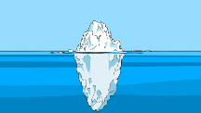  Freud believed all behaviour and feeling was influenced by unconscious drives which stem from childhood experiences.  Iceberg Analogy: under the water is the unconscious, an aspect of ourselves we are unaware of.  Preconscious: under the surface is the preconscious where dreams and parapraxes seep through  Conscious: above the water- our current and present awareness  Tripartle personality:  ID –demands instant pleasure  EGO – in contact with reality and responsible for compromise to reduce tension  SUPER EGO – morals and responsibility for guilt and pride  Defence Mechanisms – protect the ego and reduces conflict and anxiety between ID and the superego. DENIAL, DISPLACEMENT and REPRESSION
 | Biological - NATURE | Behavioural - NURTURE | Cognitive - THINKING
 | All behaviour is internal (brain, genes, neurochemistry, hormones, evolutionary)  Monozygotic twins -(100%) dizygotic twins (50%). The higher the concordance rate the higher the genetic basis.  Genotype (DNA code) and Phenotype (external feature)  Brain structure – 4 lobes  Neurochemistry –Serotonin and Dopamine  Serotonin: affects both emotions and motor skills. Serotonin is the chemical that supports sleeping, eating and digestion.  Dopamine: controls bodily movements and emotional responses. Dopamine deficiency is related to mental health conditions such as depression  Evolutionary theory – Adaptation and Innate  Evolutionary psychologists explain human behaviour based on Charles Darwin’s Theory of Evolution. This theory states that species survive through ‘NATURAL SELECTION’; a process where those who adapt to their environment tend to survive and produce offspring.  Strengths – scientific/real world application/ nature nurture diathesis stress model  Limitations – biological reductionism/determinism/lab based, ignores environment | Pavlov and Skinner – All behaviour is learnt and only measure observable behaviour.  According to the behaviourist approach, when we are born, our mind is like a ‘tabula rasa’ - in other words, a blank slate  Pavlov used dogs to develop the concept of classical conditioning and Skinner used pigeons to develop the principles of operant conditioning:  Classical Conditioning --> learn through association  Operant Conditioning--> learn through positive and negative reinforcement  Strengths – controlled environments, scientific, real-life application  Limitations – animals used – which can be unethical. Ignored biological factors.  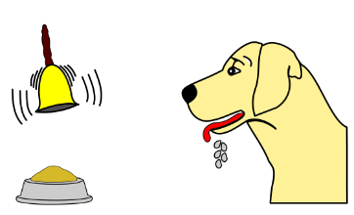 | Internal mental processes. We rely on inference to predict behaviour and use models.  Input  Process  Output  We develop a schema (mental shortcut) to help understand the world --> this can lead to stereotypes.  Cognitive Neuroscience – combination of cognitive and biological. Study of brain structure and neurology.  Strengths – real life application/lab based  Limitations – lab based – reductionism
 | Brain Functions (biological) | Social Learning Theory (behaviour) | Psychodymanic Approach
 | The cerebral cortex can be divided into four sections, which are known as lobes:  1. Frontal lobe: located at the front of the brain. Responsible for problem solving.  2. Parietal lobe: located in the middle section of the brain. Responsible for sensory processes such as pain.  3. Occipital lobe: located at the back of the brain. Responsible for interpreting visual stimuli.  4. Temporal lobe: located on the bottom section of the brain. Responsible for auditory information  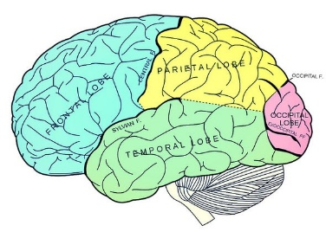 | Observation and vicarious reinforcement = identification  Mediational Process:  - Attention  - Retention  - Motor production  - Motivation (vicarious reinforcement)  BANDURA – BOBO DOLL EXPERIMENT  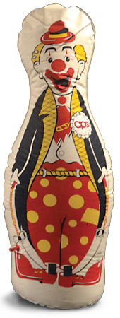  Bobo Doll --> role models -->72 children-->all imitated their model  Strengths- explains cultural norms/mediational processes  Limitations- lab study/ignores biology/difficult to test | Psychosexual Stages  Stages that each child progresses through. They experience conflicts at each stage that they must resolve.  - Oral  - Anal  - Phallic  - Latency  - Genital  Psychoanalysis  Psychological problems are rooted in our unconsciousness which create symptoms:  - Dream analysis  - Free association  - Freudian slips  - Transference relationships  Oedipus Complex  During the phallic stage boys will develop unconscious desires for his mother and will want to rid of their rival father. They develop castration anxiety and eventually identify with their father.

